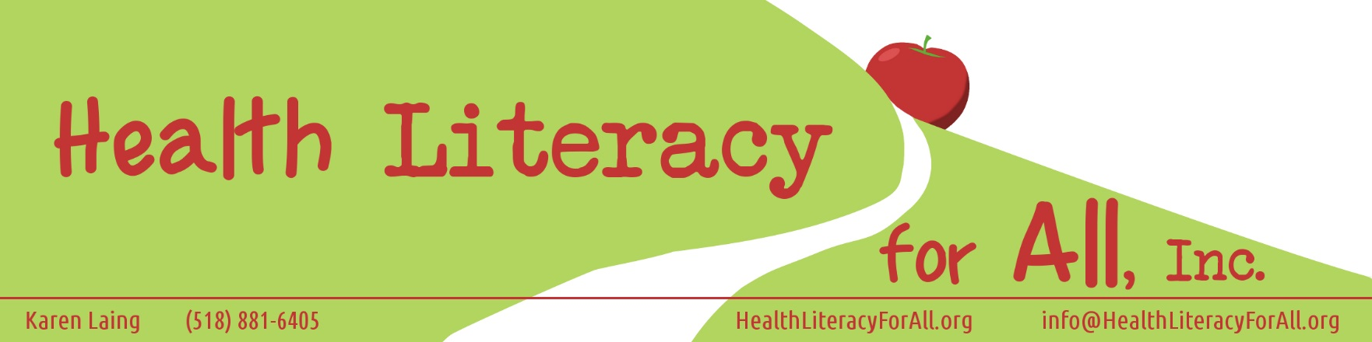
60- 90 Minute Classes to Improve Health Literacy Skills
10 Questions Everyone Must Ask Before They Pick Health Insurance
Using Your Health Insurance Wisely
Aging with Style- accepting help graciously
Nutrition for Life
Healthy Living on the Run (for employees who work primarily from their cars)
Bullying…Don’t be a Victim, Be Someone’s Health Hero
Using Your Medication Wisely- what happens when side effects impact your world
Medication Compliance- A choice with consequences
Emergency Preparedness and Chronic Illness
Emergency Preparedness for seniors and their families
I Can Boil Water…Maybe- Emergency Preparedness for kids and teens
Communicating with Your Doctor and Family
Communicating with Your Doctor, Your Family, and Your Employer about Your Health
Your Mother Can’t Go with You Forever: Teaching teens to be health literate
Domestic Violence and its Complications on Future Health
Um, Doc….I Used to be an Addict: Long term health concerns every former addict should know
I Need to See Who?- Using medical specialists effectively
Dentist and Hearing and Vision, Oh My- Using those other specialists well
Oops, I Broke a Neuron- Dealing with mental health issues
Baby Blues vs Life’s Lemons: Understanding different forms of depression
Dogs and Dementia: Using animals and nature to reconnect
Pets and Health: How animals and nature improve long term health
Meeting the Spiritual Needs of Seniors
Social and Spiritual Health: The ignored side of healthy living
Cancer and Seniors: Understanding How Aging Impacts Cancer
Stress: The Good, the Bad, the Ugly
Beating the Winter Blues
Diabetes, Diets, and Deep Inside
Footwear, Falling and Finishing with Flair
Heart Disease: A Public Health Perspective on Prevention
Hey, What Ever Happened to? VS HIPAA: For seniors and their communities
I Wear My Sunglasses at Night: Protecting Your Eye Health
Water, Water Everywhere and Not a Drop to Drink: The dangers of dehydration
When You Know It’s Time to Go: Hospice and Palliative Care
Suicide Prevention: Can you ask THE question?
Vaccines for Life
Understanding Dementia
Organizing Your Health
Pain, Pleasure and Pills: Understanding relief vs addiction
Heroin’s Here: We Cannot Hide Anymore
Developing Healthy Friendships
Independence Vs Health and Safety
Beyond Health: Top 5 Tips for Senior Wellness
COPD, Emphysema, and Asthma: Breathing Better
Stop Smoking 1: Understanding the quitting process and avoiding cravings
Stop Smoking 2: Cravings, Stress Reduction, and Modifying your Life

Bridges Out Of Poverty Classes
Bridges Out of Poverty classes train on the individual, organizational, and community impact of poverty and developing resources to help those in poverty become sustainable. Our trainer is a life-time certified BOOP trainer.

Your Business through the Lens of Poverty
Mamma Rules Vs Work Rules: Navigating the Home Health Agency World (for HHA’s and CNA’s)
Tyranny of the Moment and the Non-profit World
Poverty: What Every Church Should Know
The Medical System through the Lens of Poverty

8 hour Staff Development Classes
Advocacy, Health Literacy, and the Impact of Poverty
Health Literacy and the Impact of Poverty: Navigating the Health Care System
Health Literacy and the Impact of Poverty: Making Healthy Choices
Health Literacy and the Impact of Poverty: Emergency Preparedness

Classes for Faith Communities
GOD’s View on Healing- from the Miraculous to Sickness unto Death.
Praying for Others- Are You Covering it All?
Reaching Out- Meeting Physical/Emotional/Social/Spiritual Needs in Your Community
Setting Up or Expanding a Care Ministry- a holistic approach to caring for the sick
Creating a Health and Wellness Focus
Building a Healing and Prayer Team
Poverty: What every Faith Community Should Know
Digging Deep without Falling In
In Sickness and In Health: A look at Marriage
Are Your Seniors Spiritually Healthy Enough to Die?
Suicide Prevention for Churches: Being A Safe Space to Talk
Depression, Grief, and Anxiety: Recognizing the Illness, Caring for the Person

